Monday, November 2, 2020.

Dear Resident,

As you may have noticed, this past summer Hydro One removed a lot of vegetation along the hydro corridor adjacent to your homes. This was move was not welcomed by many residents. As such, we met with Hydro One and learned more details about funds available from a Beautification Fund to replant vegetation in the corridor that will be acceptable to Hydro One, ie. vegetation they feel won’t interfere with their operations.

Hydro One has provided our office with a list of possible trees and bushes that they could replant. If you are interested in seeing the list and sharing your opinions, please contact Tom in my office (tom.pechloff@ottawa.ca). He will send you the list and compile all the results from the emails he receives. While we are only flyering homes adjacent to the corridor, for the purpose of a broader public consultation, we will also send the list to the Hampton Iona Community Group and I’ll also put this in my weekly newletter. If you know anyone else in the neighbourhood who may want to contribute to the discussion, by all means let them know.

While we will not be able to restore the corridor, it’s my hope that with your help, we will be able to make some significant improvements here moving forward.

Cordially,
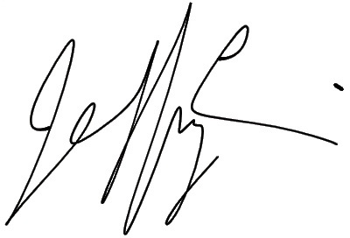

Jeff Leiper
City Councillor, Kitchissippi Ward 15
City of Ottawa
110 Laurier Ave. W
Ottawa, ON K1P 1J1

kitchissippiward.ca
613-580-2485
@KitchissippiOtt
KitchissippiWard

