Ontario Supporting High Priority Communities

Funding will provide community outreach, increased testing and wraparound supports
BACKGROUNDER December 21, 2020

The Ontario government is moving quickly to put in place a targeted High Priority Communities Strategy that will provide funding to local lead agencies to work in partnership with Ontario Health, public health units, municipalities, and other community partners to deliver key interventions for the province’s hardest-hit neighbourhoods.

Evidence shows that racially diverse, newcomer and low-income communities have been impacted more significantly by COVID-19 than others, and they need specific supports as they are facing complex barriers to accessing services and enacting core prevention measures.

Through this initiative, $12.5 million in funding will be invested to support lead community agencies and community partners in 15 priority neighborhoods in Durham, Peel, Toronto, York and Ottawa. These jurisdictions were selected due to their high-COVID-19 prevalence (current or historical), low testing rates, and sociodemographic barriers to testing and self-isolation. Additional funding of $42 million will also be available to establish isolation centres.

Actions in the strategy include:
- Tailored community outreach and engagement to enhance awareness of the services and supports available, including:
  - Teams of Community Ambassadors to provide door-to-door outreach, promoting access to available services and supports, and supplying masks and hand sanitizer kits; and
  - Developing targeted and culturally appropriate communications to ensure community members and leaders have the information needed to combat misinformation and myths.

- Increased access to testing, including more locations tailored to the unique needs of Ontario’s many and varied communities, transportation assistance, expanded and flexible hours of operation, and the use of rapid testing. In addition, Ontario Health Regions continue to develop community partnerships to understand and support addressing barriers to testing. Currently 35 sites are open, made up of assessment centres, pharmacies, and community labs, with additional testing sites opening in the coming weeks.

- Wraparound supports using a case management approach to connect individuals and families with available services, such as groceries and essentials, and emergency financial assistance so they can isolate safely at home, in a hotel, or at a designated isolation facility.

Isolation Facilities
- Currently, there are isolation facilities in Toronto, Peel and Ottawa.
- The province is planning to work with its local partners to increase existing isolation facility capacity and create new facilities, in the designated communities. The facilities will provide safe places to isolate as well as supports and services, such as meals, security, transportation and links with health and social services.
- Community case managers will coordinate access to a range of wraparound supports, including emergency financial assistance. This support will be provided to individuals required to isolate to ensure that they can meet their existing obligations including rent and other basic needs. Many individuals are eligible for federal supports, as well as up to $733 in provincial support to help with short-term financial obligations. This support will be provided to individuals in financial need in high-priority communities who are waiting for test results, are sick (COVID-19 positive or likely positive), or are required to self-isolate.
Priority Communities
The 15 high-needs communities identified to date include:
- Bramalea
- Brampton
- South West Mississauga
- East Mississauga
- North West Mississauga
- North Etobicoke Malton West Woodbridge (Peel)
- North Etobicoke Malton West Woodbridge (Toronto)
- East Toronto
- Scarborough North
- Scarborough South
- Western York Region
- Eastern York Region
- North York West
- Durham West
- Central Ottawa
The province will continue to work with Ontario Health and Public Health Units to expand the list of priority communities, which could include Hamilton and Windsor. The government will also continue to monitor the public health trends and engage with local authorities and health experts to assess the need for potential additional initiatives and funding.

Highlighting the Patient Journey

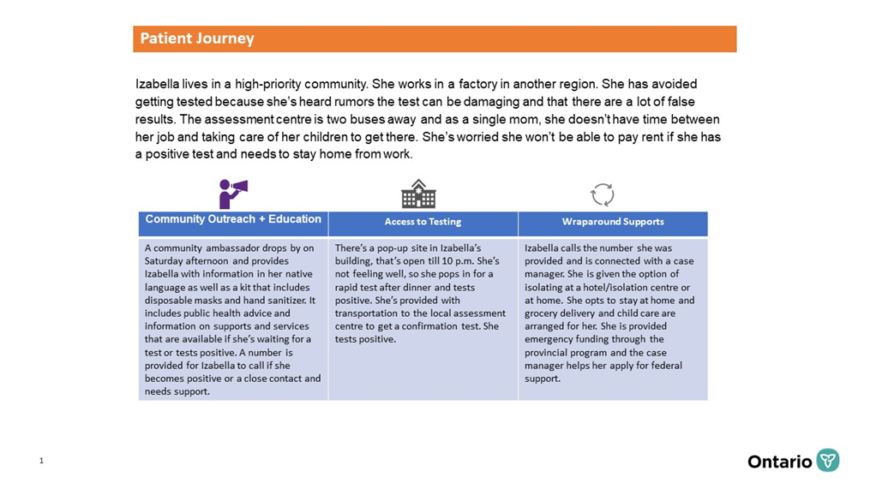

MEDIA CONTACTS
Ivana Yelich
Premier’s Office
Ivana.Yelich@ontario.ca

Alexandra Hilkene
Minister Elliott’s Office
Alexandra.Hilkene@ontario.ca

ontario.ca/health-news
Disponible en français

