Information Sheet – Questions & Answers
Bayview Friendship Park, 128 Bayview Road

Environmental Remediation & Risk Management Program
Q1 – What was the historical use of this site?

A1 – Historically the park was occupied by a number of residential dwellings; those on the portion of the park fronting onto Bayview Road were demolished between 1956 and 1965. This parcel was then owned by a general contractor from 1969 to 1972, and by the Regional Municipality of Ottawa-Carleton from 1972 to 1983. The site was leased to the City of Ottawa for use as a park beginning in 1978 and was expanded to include the lot on Hilda Street in 1979 following a fire that destroyed the residential dwelling. The current play structures at the park were installed in 2004.

As shown in the aerial image below, there were also a number of historical industrial operations in the vicinity of the site, including a large roundhouse and ancillary rail-related structures immediately north of the park. The roundhouse was operated by Canadian Pacific Railway (CPR) and was decommissioned in 1970 prior to the development of the Tom Brown Arena in 1978.

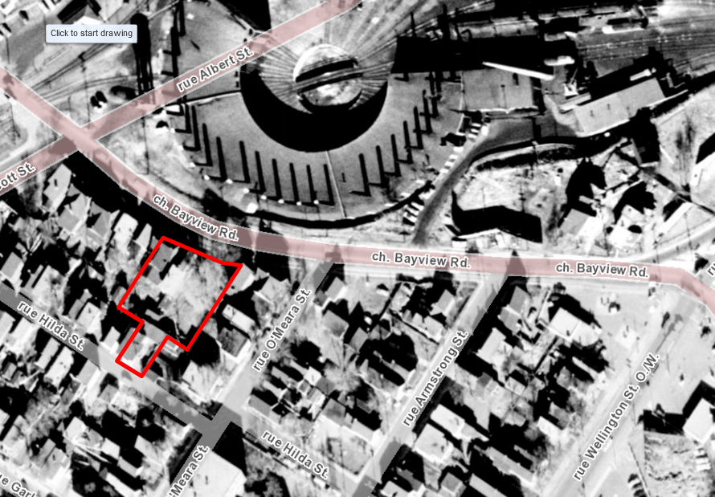
Bayview Friendship Park – circa 1958

Q2 – What environmental investigations have been completed at the site?

A2 – In support of the proposed park improvements, a series of environmental investigations were completed at Bayview Friendship Park in 2016 beginning with a Phase I Environmental Site Assessment (ESA). The Phase I ESA identified several potential environmental concerns at the site including the quality of fill that may have been used to backfill and grade the site following demolition of the former structures; the presence of ash from the fire that destroyed the former dwelling fronting onto Hilda Street; lead paint which may have been present on the former structures; and the proximity of the site to the former CPR roundhouse. A Phase II ESA was recommended to investigate soil and groundwater quality at the site.

The Phase II ESA completed in 2016 included advancement of boreholes across the site, several of which were installed with monitoring wells to evaluate groundwater quality. The investigation identified a layer of fill across the park which contained concentrations of various polycyclic aromatic hydrocarbons (PAHs) and metals in excess of the applicable Ontario Ministry of Environment, Conservation and Parks (MECP) Table 7 site condition standards for residential/parkland land use. The fill layer also contained ash, cinders, brick and/or coal at some locations. No impacts were found in any of the groundwater samples tested at the site.

In light of the initial findings, additional testing of the shallow soil and playground sand was completed in 2017. No exceedances for metals or PAHs were identified in any of the sand samples collected from the playground area or in the majority of the shallow soil samples analysed across the site (shallow soil samples were generally collected to a depth of 10 cm, while playground sand was sampled to a depth of 25 cm). Of the 28 shallow soil samples collected, only four locations reported exceedances of one or more PAHs relative to the component value protective of human health exposure. Additionally, the locations reporting exceedances were isolated from play areas with one situated in a raised bed planter behind the playground equipment and the remainder located on the upper portion of the park near Hilda Street which serves mainly as a pass-through area for playground users.

Q3 – What types of contaminants were found at the site?

A3 – The environmental investigation completed in support of the park improvements at Bayview Friendship Park identified soils with concentrations of polycyclic aromatic hydrocarbons (PAHs) and metals (lead and mercury) at levels exceeding the current MECP standards for parkland use.

PAHs are a group of more than 100 chemicals that are generated from the incomplete combustion of fuels, waste or other organic substances. The dominant sources of PAHs in the environment are associated with human activity and they are commonly found in older urban areas, particularly those used for industrial purposes and/or manufacturing. PAHs are contained in asphalt, crude oil, coal, coal tar pitch, creosote, vehicle exhaust and can occur throughout the environment in the air, attached to dust particles, or as solids in soil or sediment.

Metals contamination in urban soils can be attributed to a number of sources including building materials, paints, fertilizers, treated timber, aged infrastructure, vehicle emissions or other general commercial/industrial wastes.

The soil impacts at Bayview Friendship Park are likely associated with the presence of ash and cinders in the fill layer identified across the site. It is unknown if the poor quality fill was placed at the site following demolition of the former residential dwellings at the site or at another period in time; or whether it was impacted by the fire which destroyed the dwelling fronting onto Hilda Street.

Q4 – Why are these types of contaminants in soil a potential health risk?

A4 – The contaminants identified in the soil at the site can be harmful to human health under some circumstances. Several PAH compounds are potential cancer-causing agents and benzo[a]pyrene is a known carcinogen. PAHs can also be skin irritants.

Everyone is exposed to some amounts of PAHs and metals through air, soil, household dust, food, drinking water and various consumer/household products. The effects of PAHs and metals will depend on the extent of exposure (duration and frequency), the amount one is exposed to (relative concentration), the nature of the exposure (via inhalation, ingestion or skin contact) along with general characteristics associated with the person being exposed (age, pre-existing health conditions, etc.). Children are more susceptible to exposure as they tend to play on the ground surface and may consume small amounts of soil due to frequent hand-to-mouth activities.

Although contaminated soil has been identified at the site, there must be direct contact with or disturbance of the soil in order for any health risk to occur. Furthermore, prolonged and repeated direct exposure would generally be required for any actual hazard to occur.

Q5 – Does the contamination identified at the park currently pose a human health risk?

A5 – Exposure to the underlying impacted fill is generally limited by the presence of clean topsoil, grass and sand over the majority of the site. The four shallow soil samples that exceeded the human health component values were found in areas of the park isolated from play areas. While health effects can arise from exposure to PAHs and metals, it is important to note that the potential risks associated with these levels of contamination are calculated based on a lifetime worth of exposure and would generally require prolonged and/or repeated direct oral and/or skin contact with the impacted soil in order for a health hazard to occur. The risk management program to be implemented at the site will further reduce risk by eliminating or preventing exposure to the underlying impacted fill identified at the site.

As previously noted, no impacts were identified in the groundwater tested at the site and the soil contamination does not constitute a risk to the City’s drinking water supply. The majority of the urban area in the City of Ottawa is connected to the municipal water supply which draws water from the Ottawa River and undergoes extensive monitoring, treatment and testing to ensure a safe drinking water supply for Ottawa residents.

Q6 – What is the City’s plan to address the contaminants at Bayview Friendship Park?

A6 – In conjunction with the planned park improvements in the fall of 2018, the City’s Environmental Remediation Unit will implement a remediation and risk management program to remove or isolate the underlying contaminated soils at the park.

In the upper portion of the park near Hilda Street, the environmental drilling program encountered bedrock at shallow depths, therefore in this area the impacted soil will be removed to the bedrock surface and replaced with clean imported soil. Over the lower portion of the park near Bayview Road, bedrock was encountered at greater depths; and as a result the risk management program over this area will involve an approach referred to as ‘soil capping’. This involves removal of impacted fill to a depth of 0.5 m and replacement with clean imported material (either a combination of granular base and engineered wood fibre for the playground area and soil/grass for the landscaped areas). A geotextile fabric will also be placed as a demarcation barrier between the clean soil cap and the underlying impacted soils that will remain in place.

The addition of the soil cap and the overall park improvements may result in some minor alterations to the elevations and grading of the project area, however the redevelopment landscape design will ensure smooth transitions with existing features surrounding the park.

Q7 – Will existing mature trees in Bayview Friendship Park be negatively impacted by the remediation project?

A7 – A tree inventory was completed in advance of the park improvements, which indicated that the majority of the existing trees at the park are in fair to poor condition. The three Norway Maples trees in the central area of the park were identified as being in good condition and will be retained. Additional soil samples collected from the critical root zones of these three trees indicated that there was at least 30 cm of clean topsoil throughout this area. Thirteen new trees will be planted at the park as part of the project.

Q8 – Will the community be exposed to unacceptable levels of contamination during the remediation project?

A8 – During the project, the work area will be surrounded by construction fencing and only authorized personnel will be able to access the site. This will eliminate any direct exposure to the impacted soil during the project. To limit potential exposure from inhalation of dust particulate, the contractor will be required to develop and implement a dust control plan as part of the project. The plan will include steps to prevent fugitive dust emissions at the site and adjacent properties as well as to prevent vehicle tracking of soil onto the surrounding municipal roadways. An environmental consultant retained by the City will be on-site during periods of soil excavation to ensure that dust mitigation measures and other project specifications related to the environmental risk management program are being implemented.

Q9 – How will the site be monitored to ensure that the risk management measures are successful?

A9 – An environmental consultant retained by the City will be on-site for the duration of the project to supervise the remediation work. Following completion of the project, the site will be inspected and maintained on a regular basis to ensure the continued integrity of the clean soil cap. Any required repairs will be made forthwith and a record of all inspections, deficiencies and repairs will be maintained by the City. Any future use of the site for community gardening purposes would require raised beds with clean imported soil in accordance with City policies.

Q10 – Is Ottawa Public Health involved in this project?

A10 – Ottawa Public Health (OPH) was consulted as part of the planning of the remediation project, and has reviewed the information provided in this fact sheet. For any concerns or health related questions, community members are welcome to contact OPH at (613) 580-6744.

Q11 – When is the remediation work expected to begin and for how long is the park expected to be closed?

A11 - The estimated start date for the park improvements including the environmental risk management program is fall 2018. The exact start date will be communicated to residents once it has been finalized with the contractor. The playground area will be closed for the duration of construction. It is anticipated that the park will be re-opened to the public by late 2018; however there may be some elements of the park improvements that will need to be completed in spring 2019 (e.g., tree planting).

If you have further questions regarding the environmental conditions and/or risk management program that have not been addressed, please contact:

Erin Tait
Specialist, Environmental Remediation
Corporate Real Estate Office, City of Ottawa
Phone: (613) 580-2424 ext. 12958
erin.tait@ottawa.ca

If you have further questions regarding the planned park redevelopment that have not been addressed, please contact:

Jeannette Krabicka
Planner 2, Parks and Facilities Planning
Recreation, Cultural and Facility Services, City of Ottawa
Phone: (613) 580-2424 ext. 20047
jeannette.krabicka@ottawa.ca

